**Resilient Vulnerabilty © Mark Seton 2006**

‘Resilient vulnerability’ – it is not about attempting to minimise risk-taking.

Attempting to minimise risk-taking would foster a denial of the inevitability of woundedness in our lives and in our interactions with each other.

Instead, resilient vulnerability is about preparing for each creative task or journey with resources and support (on call) to engage with creative practices and processes without slipping into unintended or unsustainable discomfort and trauma.

I have identified 7 elements (Presence, Perception, Preparation, Process, Perspective, Partnership and Play) that foster **Resilient Vulnerability©**. As a system that I have taught actors and musicians, these elements enable creatives to be more resilient while retaining a necessary vulnerability to engage in creative, risk-taking work.

Resilient risk-takers!

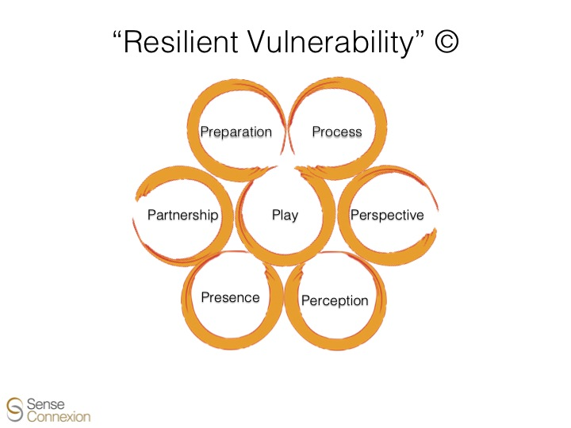

These inter-dependent elements engage the following practical questions:

**presence** (what do I notice in my own self/body as I prepare to create?)

and

**perception** (what do I perceive in the world and how do I make sense of my experiences?)

**preparation** (how does my prior training, as a creative, affect the ways I behave in response to my experiences and interactions with others?)

and

**process** (how do I actively carry out creative tasks, as an artist, and remain responsive to my ongoing experience in relation to others?)

**partnership** (who are the people who can support me and ground me as a professional?)

and

**perspective** (what are the social/cultural/economic/political contexts of the creative industries in which I need to make choices about how and when I will make connection with others?)

and

**play** (how do I remain flexible and playfully risk-taking, open to new insights in each of these 6 elements?)